**8 RELAY MODBUS**

* To Install Software Double click on the setup file.
* After Installation .The Software will open as shown below(fig 1)

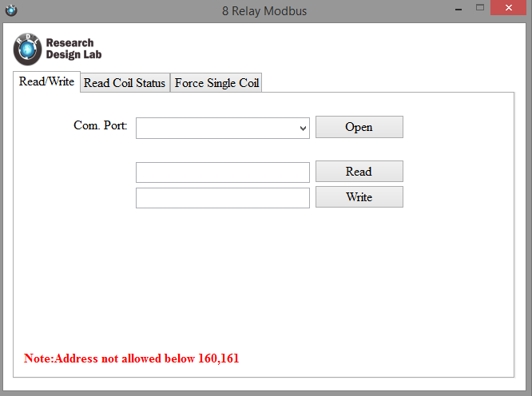

Fig 1

* Select the Com.Port and click Open Button as shown below(fig 2)

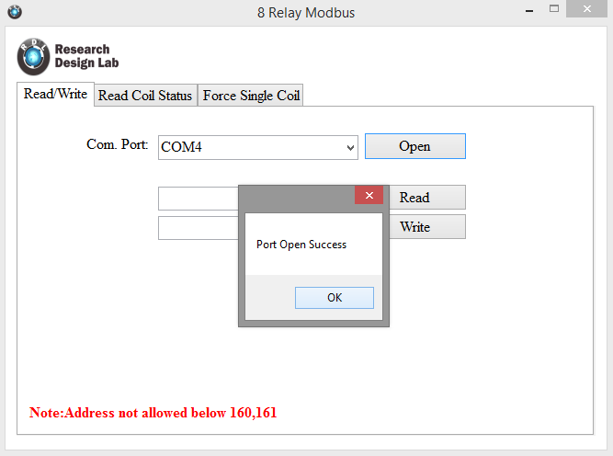

Fig 2

* Enter the Address and Click Write Button(fig 3)

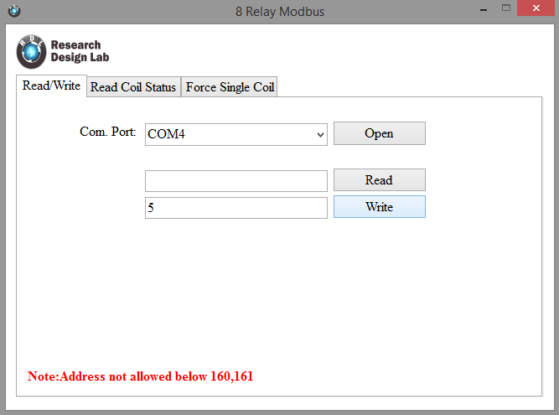

* Click on Read Button to Select the Address to set the relay on/off (fig 4).

Fig 3

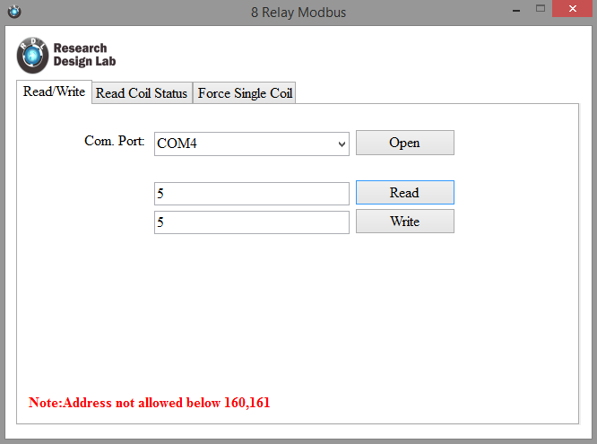

Fig 4

* In Force Single Coil tab, you can switch the relay On/Off by clicking the buttons. Before switching ON(fig 5)

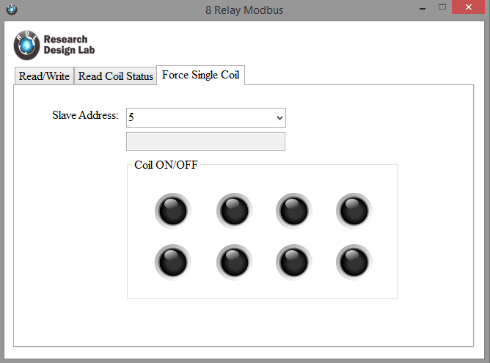

Fig 5

* After Switching ON(fig 6)

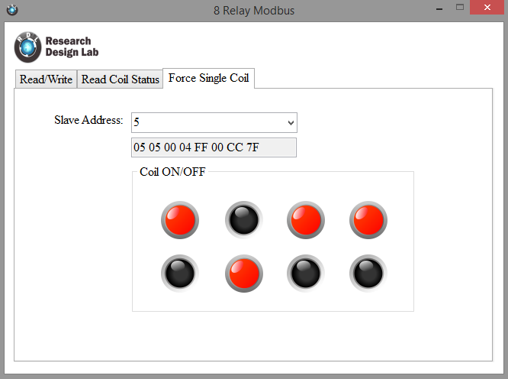

Fig 6

* To read the Relay status, Move to Read Coil status Tab and click on Read Button, It will show you the corresponding relays that are ON for the Address. Before Read(fig 7)

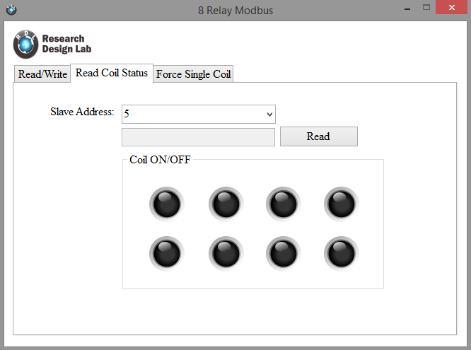

Fig 7

* After Read(Fig 8)

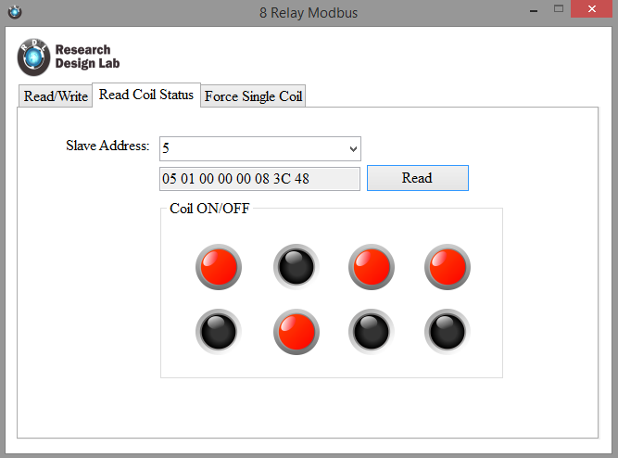

Fig 8

* To Switch OFF Relay go to Force Single Coil Tab and Click on Buttons that are ON to Switch it OFF.

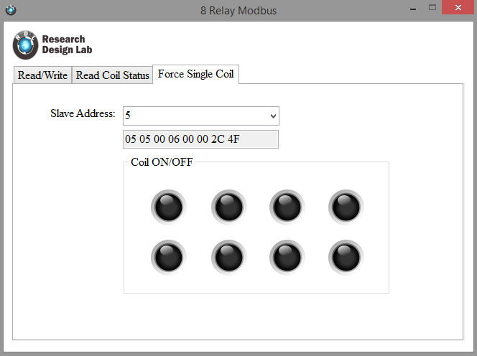

Fig 9

************************************************************* RDL Technologies Pvt.Ltd